**Instructions for Modified Thornthwaite Water Balance Model in Excel**

This model and instructions created by David Thoma, U.S. National Park Service, Bozeman, MT

Ver Daymet_Penman_Hamon_Batch_v3.xlsm

Updated 12/18/2020

Table of Contents

**Running the model for a single location** 1

**Inputs** 2

Outputs 3

Annual 3

Monthly 4

Daily 4

**Manual calibration at a single location** 4

**How to enable macros for calibration and batch processing** 6

**Batch processing many sites** 6

**Obtain many DAYMET data files for batch processing** 7

Manual download 7

Java batch download 7

R batch download 8

**Run water balance model in batch mode** 8

**R script for stacking water balance results into long format** 9

**How to Obtain Soil Water Holding Capacity in United States** 11

**Exploring the influence of PET method, site and climate** 22

**References** 22

# **Running the model for a single location**

1. Determine latitude and longitude of location that you want to model, units must be in decimal degrees. You can do this in several ways.
   1. In Google type “lat long Fayetteville, AR” (this is the easiest method)
      1. 36.0822° N, 94.1719° W
   2. In Google Earth navigate to your location and write down the coordinates
2. Obtain Daymet daily climate data
   1. <https://daymet.ornl.gov/single-pixel/>
   2. If asked, create a free login profile and sign in.
   3. Drag the pointer to your location of interest or
   4. Enter your coordinates manually obtained from step 1. Set up drop downs like this.
   5. NOTE: Longitude must be **NEGATIVE**

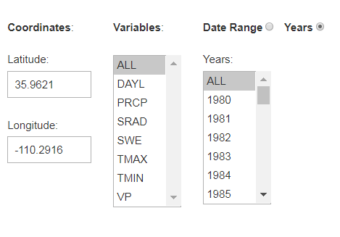

Select the “years” radio button, then select all variables and all years

* 1. Click “Download Data” and a *.csv file will download in a few seconds
  2. Open this file and also Water Balance Model spreadsheet “Simple Water Balance Model.xlsx”
  3. Enable iterative calculations in “Simple Water Balance Model.xlsx”
     1. Click File>Options>Formulas>check box “Enable iterative calculations”
  4. Paste the Daymet climate data into Water Balance Model spreadsheet tab called “paste Daymet data here”
  5. **IMPORTANT** last step. In the tab “paste Daymet data here” format cell A1 to separate the Latitude, Longitude and Elevation values and into separate cells in their respective rows
     1. Click Cell A1 then on the top ribbon click
        1. Data > text to columns > delimited > space > finish
     2. Repeat for cell A4
  6. Your daily water balance results are automatically calculated starting in column BB.
  7. Refresh both the “annual” and “monthly” tabs to update the pivot tables that build annual and monthly outputs from the daily output
     1. Right click any cell on the tab and then click “refresh”

**Inputs**

Required:

Max and Min Temperature (deg C)

Precipitation (mm)

Latitude (decimal degrees)

Optional:

Water Holding Capacity (mm)

Slope (degrees optional)

Aspect (degrees optional)

Site name

Solar radiation (W/m^2)

Vapor pressure (Pa)

Wind speed (m/s)

Shade coefficient (0 to 1) multiplier that reduces PET

Input climate data are located in the sheet “paste_Daymet_data_here” in columns A:I.

Latitude and elevation used in calculations must be in their own cells B1, and B4, respectively.

Other model input parameters are highlighted in yellow beginning at column BB.



DRO = Direct runoff (BB7)

Location = site name (BD5)

T50 = Jennings coefficient, or temperature for rain / snow transition (BE5)

Pack initial condition = mm of snow pack snow water equivalent (BH7)

Hock melt factor = mm of daily snowmelt when warm enough to melt (BI7)

Soil initial conditions = mm soil water stored in soil profile (BM7)

Slope = site slope in degrees (BP5)

Azimuth = slope aspect in degrees (BR5)

Tbase = Base temperature for calculating growing degree days (BS6)

Shade = fractional reduction in PET due to shade (0-1) (BV6)

Wind = wind speed (m/s) (BW6)

Soilmax = mm water holding capacity of soil (BX6)

Output units are mm for all water related terms and degrees Celsius for any temperature related term. Separate output files are created for daily, monthly and annual periodicity

# Outputs

## Annual

Row Labels– year of annual summary

Sum of P- annual sum of precipitation

Average of T– annual average temperature

Sum of RAIN– annual sum of precipitation as rain

Sum of SNOW– annual sum of precipitation as snow water equivalent

Max of PACK–maximum annual snow pack as snow water equivalent

Sum of MELT– annual sum of snow melt as water

Sum of W– sum of melt plus rain reaching soil surface

Sum of PET– annual sum of potential evapotranspiration

Sum of W - PET– annual sum of melt plus rain reaching soil surface minus potential evapotranspiration

Average of SOIL– annual average soil moisture

Sum of AET- annual sum of actual evapotranspiration

Sum of W-ET-/\SOIL– annual sum of excess water after available water holding capacity of soil saturated, also called runoff

Sum of D-annual sum of deficit which is PET-AET

Sum of GDD– annual sum of growing degree days

site– site name

Monthly

Same as annual

## Daily

date - date

year - year

month- month of year

day – day of year

svp -saturation vapor pressure (Pa)

rh – relative humidity (%)

vpd – vapor pressure deficit (Pa)

DRO – direct runoff, or fraction of precipitation shunted to runoff (mm)

P – daily precipitation (mm)

T – daily average temperature (deg C)

F – temperature dependent constant used to partition precipitation into rain or snow

RAIN – daily precipitation as rain (mm)

SNOW – daily precipitation as snow (mm)

PACK – daily snowpack snow water equivalent (mm) accounting for daily additions and melt

MELT – daily snow melt (mm)

W – daily water reaching soil surface as snow plus rain (mm)

PET – potential evapotranspiration (mm)

W – PET – water reaching soil surface minus potential evapotranspiration (mm)

SOIL – soil moisture (mm)

/\SOIL – change in soil moisture from previous day (mm)

AET – actual evapotranspiration (mm), which is PET limited by soil water availability

W-ET-/\SOIL – runoff, or excess input greater than soil water holding capacity (mm)

D – climatic water deficit, which is PET – AET (mm)

GDD – growing degree days (deg C)

Site – site name

Dew – did dew form overnight (y/n)

# **Manual calibration at a single location**

1. On the paste_Daymet_data here tab change any of the water balance input parameters in yellow highlighted cells then hit return.
2. Daily response: If you have daily response data paste it into “paste daymet data here” tab in column BY. Be sure to order the dates of your daily responses to match the daily daymet data by date.
3. Monthly response: If your response is monthly paste it into the monthly relations tab and align dates with water balance dates in that tab
4. Annual response: If your response is annual paste it into the annual relations tab and align dates with water balance dates in that tab
5. Once the response data you supply is aligned temporally with the water balance output on either the monthly or annual tab you can begin adjusting the model coefficients on the “paste daymet data here” tab. The coefficients are yellow highlighted cells. Make changes to these cells, then run the “refresh” macro.
6. Yellow highlighted cells can be modified by users. Cells in green are calculated by the model.  Radians are needed by the model to make calculations on a circle or globe for things like day length that varies by latitude for a given day of year.
7. P dir runoff = fraction of precipitation shunted to overland flow or deep infiltration below rooting zone, unavailable to plants either way.
8. Initial conditions: Cell BH 6 is the starting condition for snow on the ground for the day before your climate time series starts.  It's an unknown initial condition. You can guess at it or leave it zero.  Other initial conditions are in cells BM7, initial soil moisture condition. Neat thing about this model is that after a year the initial conditions are irrelevant because soil either fills or drains completely in most environments over the course of a year.
9. Slope and aspect... range 0 to steep and 0 North to 360 North again. This is for the heat load modification that accounts for N vs. South aspect conditions that affect soil drying.  We get this from field data or a DEM.  Heat load is a multiplier used to adjust reference PET which is calculated for an unshaded flat surface for a "short well-watered sward of grass" - think of a rough at a golf course.
10. Shade coefficient adjusts PET down.  It's a multiplier between zero and 1 that you can adjust if you're modeling sub canopy conditions.  Be careful with this term because it's probably not truly a linear multiplier but for the moment that's how it is implemented.
11. GDD base is the lowest temperature you expect biological activity.  For frogs which hop around on snow in Yellowstone we set to 0 Celsius.  For vegetation 4 deg. C.
12. Wind speed in meters/second used only for penman PET math.  Hamon equation for PET does not have a wind component
13. Soil max.  or available water supply (AWS) is NRCS jargon for available water storage which is NOT how much water is stored in the soil, but rather its water holding capacity.  This is more like the volume of a cup rather than suggesting how full the cup is. Get this from SSURGO aguatt table. Use the depth range where you think veg in site is interacting with soil moisture (default is 0-100mm?). A very low water holding capacity would force water to runoff, like a parking lot.*This is an important parameter and often has a large effect on model results and is one of most important parameters to test versus a response via trial and error.*

# **How to enable macros for calibration and batch processing**

1. Instructions to ensure macros can run and developer tab opens on the toolbar ribbon (only need to do this once)
   1. Open the Excel worksheet called Daymet_Penman_Hamon_Batch.xlsm
   2. Click “enable macros” if it asks.
   3. Click File > Options> Trustcenter>Trustcenter settings>Macro Settings > click enable macros
   4. Click File > Options>Customize Ribbon> check the Developer box to display a new tab
2. Click developer tab>Visual Basic> scroll to modules on left side pane and expand then double click Daymet_Penman_Hamon_batch to open the macro
3. If none of that works because your IT administrator blocks macros try this
   1. On the main ribbon click View > Macros dropdown

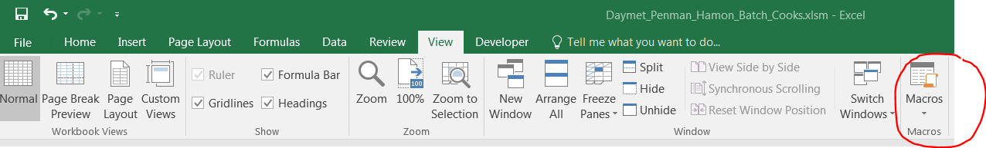

# **Batch processing many sites**

Prepare a standalone Excel site attribute file that describes your locations

1. A template is provided with the water balance model called “sites.xlsx”.
   1. 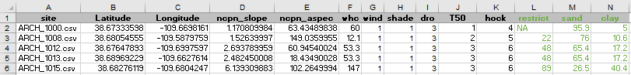
   2. Required fields are site file, LatDD, and LongDD… site name.
      1. Optional fields are slope in degrees, aspect or azimuth in degrees, water holding capacity in mm, wind speed (m/s), direct runoff fraction (%). If these are not supplied the model assumes a flat surface with 100mm water holding capacity, zero direct runoff and 1 m/s wind speed. You can change the name of column headers, but the order of parameters must be identical to this example. In order to match a daymet data file with site characteristics the code matches a daymet data file name with a site file in first column below.
      2. Green fields are optional and not used in the water balance but useful if you want ancillary data to join in R.
   3. The tab name containing site attribute information must be named “sites”. If it is named “Sheet1” rename by double clicking on the tab and rename it “sites”. Save the workbook as sites.xlsx and sites.csv.
   4. The name of the site file must have a “.csv” extension.
      1. You can add this easily to your existing site names using the concatenate function in Excel. =CONCATENATE(J1,".csv"), where J1 is cell location of site name
   5. The easiest way to get water holding capacity is from published soil surveys or gridded soil surveys from gSSURGO.

# **Obtain many DAYMET data files for batch processing**

## Manual download

1. Download climate data time series as *.csv files
2. In Chrome go to <https://daymet.ornl.gov/>
3. Click Single Pixel Tool, scroll to bottom of page and click Automate. Look in the batch download of daymet single pixel data example 2. This is the format of a file you submit to daymet for selecting your locations of interest. It looks very similar to the site attribute file in green above.

## Java batch download

1. There are multiple ways to obtain daymet data and we’ll use the java method here
   1. Click the java link, then read.me file. This provides detailed instructions but here are a few tips.
   2. Set up a folder called (i.e., C:\David\waterbalance\) with these sub folders

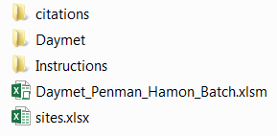

* 1. In the Daymet folder save the java script “daymet_multiple_extraction.jar” , the “read.me” file and a copy of your sites.xlsx file as a *.csv file

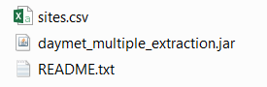

* 1. Tell the java script where to dump the daymet data files.
     1. Open a DOS command window inside the Daymet folder by holding down the shift key and simultaneously right clicking your mouse. Then select “open command window (or Powershell window for windows 10) here”. A black DOS window should open. If not make sure no files were selected (highlighted) in the Daymet path while trying to open the command window.
     2. Download data files
        1. Paste this line into your DOS window without the quotes. “java -Xms512m -Xmx1024m -jar daymet_multiple_extraction.jar sites.csv” then hit return.
        2. You will see your files downloading in the DOS window, then your Daymet folder will look like this

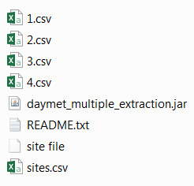

* + - 1. IMPORTANT: Delete the two files highlighted below. “site” doesn’t show up don’t worry about it.

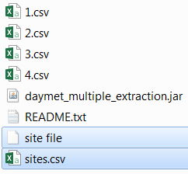

## R batch download

1. Modify the R script provided

# **Run water balance model in batch mode**

1. Set up your folder structure like this
   1. Davids water balance folder
2. Excel model
3. Sites.xlsx
4. Daymet
   1. Daymet data files
   2. Sites.xlsx (a copy of the sites.xlsx file)
5. Open the water balance model then open the VBA project window from Developer tab, double click the module called Water_balance_DAYMET_Penman_Hamon_batch then click the > run icon.
6. Follow the on-screen prompts
7. Or
8. From the main ribbon click View>Macros>highlight Water_balance_DAYMET_Penman_Hamon_batch then click run and follow instructions in pop up window. You may want to copy the path to your folder location first as you’ll need this to use the macro
9. Folllow on-screen prompts to point the model to your Dayemet data and sites.xlsx file, and choose your method of PET calculation.
   1. Penman PET is physically based
   2. OudinDaymet is temperature and radiation based using the radiation value in the Daymet file. It is a good approximation of Penman.
   3. OudinLocation is temperature and radiation based but uses the latitude to calculate a radiation value rather than that provided by Daymet
   4. Hamon is a temperature based PET equation
10. For large batches, progress can be tracked in the lower left of the worksheet screen.
11. After the last daymet data file is processed the model saves its self then closes. You’ll see a blank Excel screen. Close this window without saving it.
12. Your water balance output files are dumped to daily, monthly, and annual folders.
13. You will need to adjust sorting of monthly data to match up with dates prior to pasting into monthly tab of file. You will have to split year_month into year and month columns using the text to columns feature in Excel, then sort by year and month to get Excel to properly sort by time.

The water balance model can run without slope, aspect or soil water holding capacity by assuming a flat surface with 100mm WHC. However, more realistic results are obtained if you supply these values as input to the model. To obtain them you need water holding capacity map, slope and aspect derived from a DEM.

All of these layers must be in the same geographic projection. However, their large extents may make them unmanageable in ArcMap. You can work around this limitation by clipping the extent using a mask. Or, you can reproject your point shapefile to match the soil, slope and aspect maps. Since you’re only pulling point data from these maps they don’t all have to have the same projection as long as the point file projection used to identify locations on each map has the same projection as the map.

# **R script for stacking water balance results into long format**

This script makes an R readable file by stacking output for each site into one long file.

It does this for files in each of the daily, monthly and annual folders

# > version

# _

# platform x86_64-w64-mingw32

# arch x86_64

# os mingw32

# system x86_64, mingw32

# status

# major 3

# minor 3.1

# year 2016

# month 06

# day 21

# svn rev 70800

# language R

# version.string R version 3.3.1 (2016-06-21)

# nickname Bug in Your Hair

#convienience script for appending site level monthly water balance output *.csv files into one long file

library(dplyr)

#append the monthly files into a single data frame

setwd("C:\\David\\Water balance\\Amphib_2018\\monthly")

## read in csvs

csvList <- lapply(list.files("./"), read.csv, stringsAsFactors = F)#takes a few seconds with 770 files

## bind them all with do.call

monthly_append <- do.call(rbind, csvList)#takes about a minute with 770 files

setwd("C:\\David\\Water balance\\Amphib_2018")

write.csv(monthly_append,"monthly_append.csv")

#append the annual files into a single data frame

setwd("C:\\David\\Water balance\\Amphib_2018\\annual")

## read in csvs

csvList <- lapply(list.files("./"), read.csv, stringsAsFactors = F)#takes a few seconds with 770 files

## bind them all with do.call

annual_append <- do.call(rbind, csvList)#takes about a minute with 770 files

setwd("C:\\David\\Water balance\\Amphib_2018")

write.csv(annual_append,"annual_append.csv")

#append the daily files into a single data frame

setwd("C:\\David\\Water balance\\Amphib_2018\\daily")

## read in csvs

csvList <- lapply(list.files("./"), read.csv, stringsAsFactors = F)#takes a few seconds with 770 files

## bind them all with do.call

daily_append <- do.call(rbind, csvList)#takes about a minute with 770 files

setwd("C:\\David\\Water balance\\Amphib_2018")

write.csv(daily_append,"daily_append.csv")

# **How to Obtain Soil Water Holding Capacity in United States**

<https://gdg.sc.egov.usda.gov/>

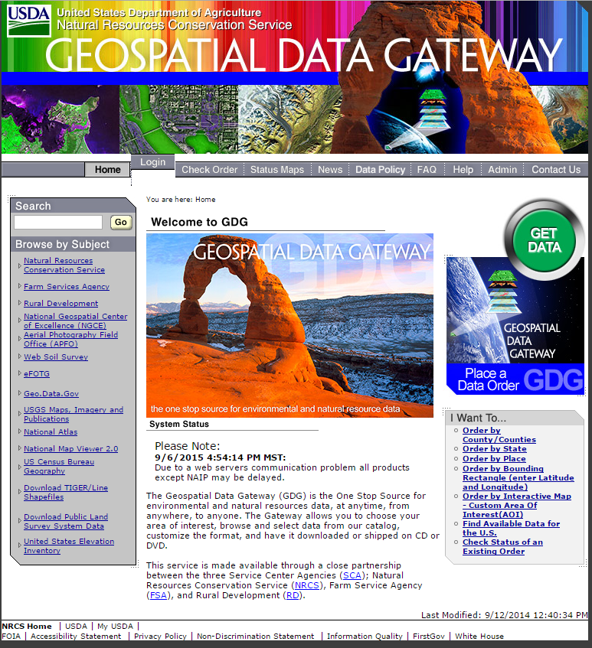

Click the Get Data button

Where:Select state and ONE single county – doesn’t matter which one, b/c entire state gets downloaded with every county level order

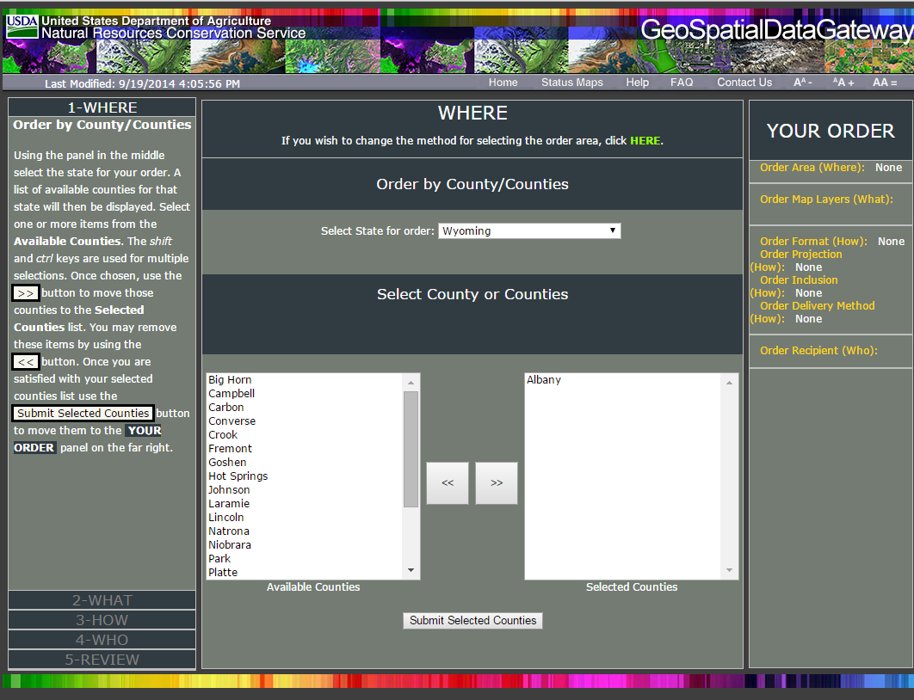

Click submit selected counties

WHAT: click gSSURGO

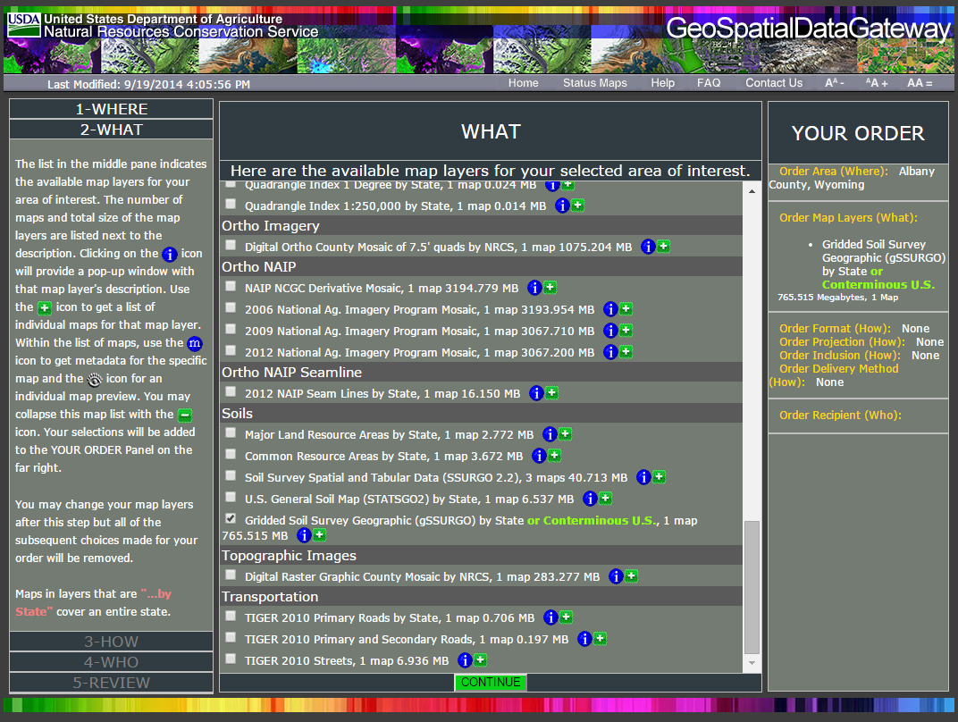

HOW: select FTP

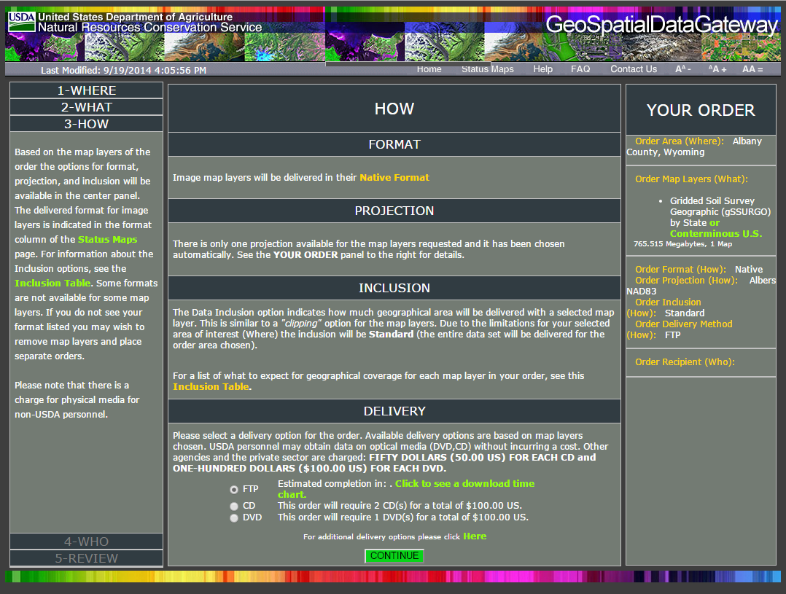

Enter personal info on next screen

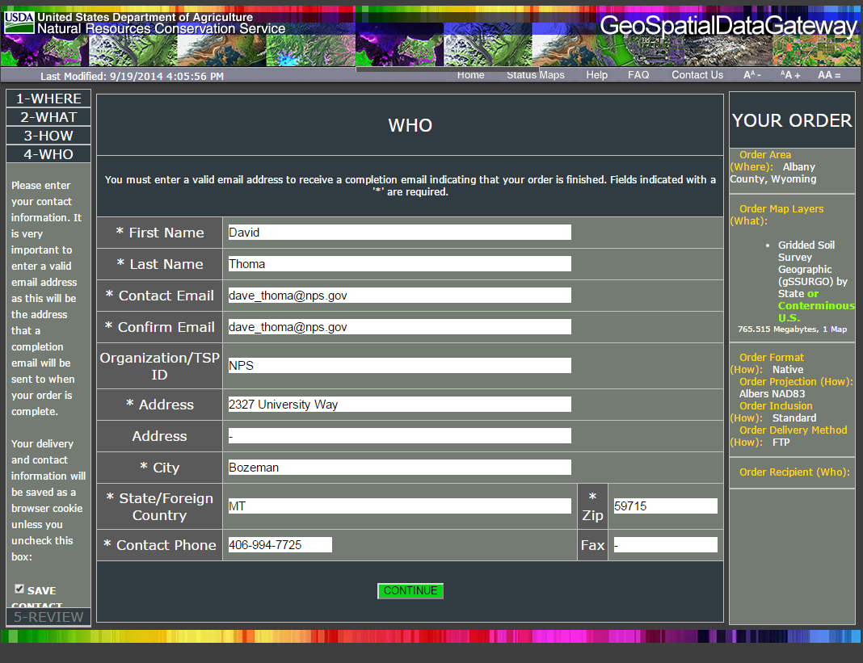

Click “Place Order” then when e-mail arrives click link to download the file.

Save the file and then Unzip file contents.

Add MapunitRaster_UT_10m to your ArcMap project. It’s the key to finding soil properties data in the file geodatabase for your state.

The Soil Data Management Toolbox for ArcGIS makes it possible to extract soil data you need to run the water balance model.

Documentation for the Toolbox can be found here.

https://www.bing.com/search?q=Soil+Data+Management+Toolbox&cvid=27b9d09966ff47eba4cbbdb435bc1ea3&aqs=edge..69i57j69i59.1801j0j4&FORM=ANAB01&PC=U531

Download the model from

<https://github.com/ncss-tech/SoilDataDevelopmentToolbox/archive/master.zip>

to this location so ArcMap can find it.

C:\Users\dthoma\AppData\Roaming\Esri\Desktop10.7\ArcToolbox\My Toolboxes

Unzip it

Open Arctoolbox in ArcMap, in the Toolbox window right click on ArcToolbox, then click Add Toolbox.

The Soil Data Development Toolbox should now appear in your ArcToolbox options.

Click it, then click gSSURGO Mapping Toolset, then click Create Soil Map.

Fill out the drop down menu options as needed to obtain properties as needed.

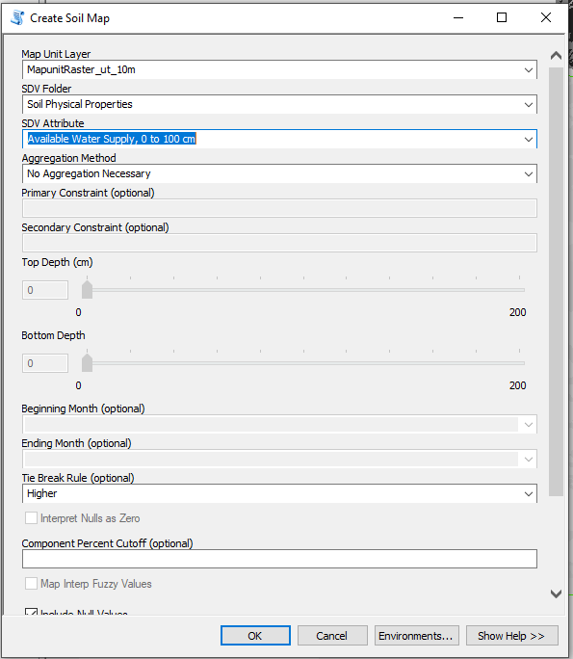

Using the User Guide that comes with the gSSURGO data

NOTE: Start on page 14 and follow instructions until page 22 where you join table info to your map.

Where it says “…browse to muaggat” you want to find the Valu path that you unzipped earlier then select Valu1 for the Join Table. Valu1 described on pg 11 in User Guide.

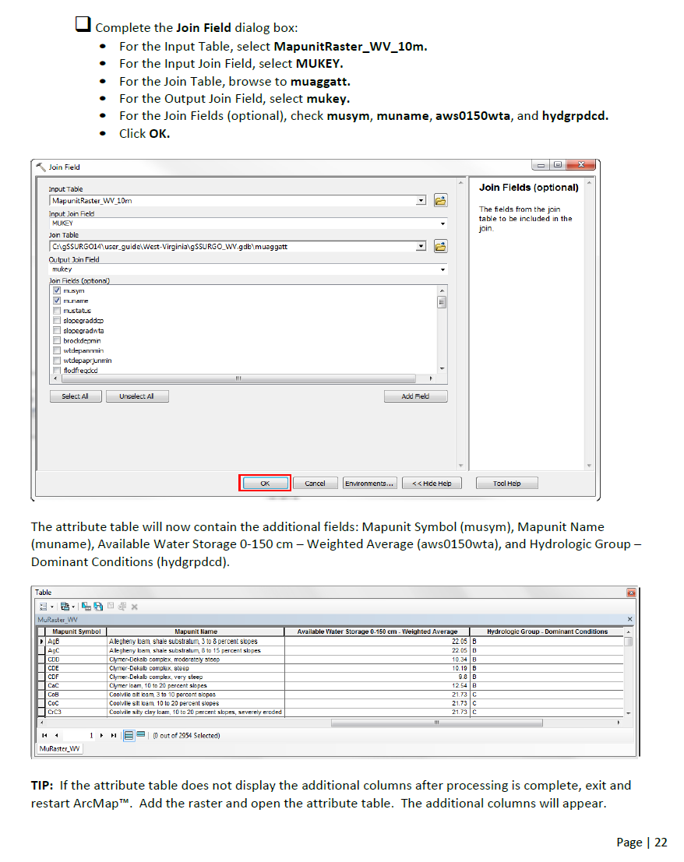

For this water balance model select Valu1 fields 0-100; 0-150 and 0-999. The last one gives the water holding capacity for the entire soil profile and will be greater for soils that don’t have bedrock at shallow depths.

Edit layer properties to display WHC by category.

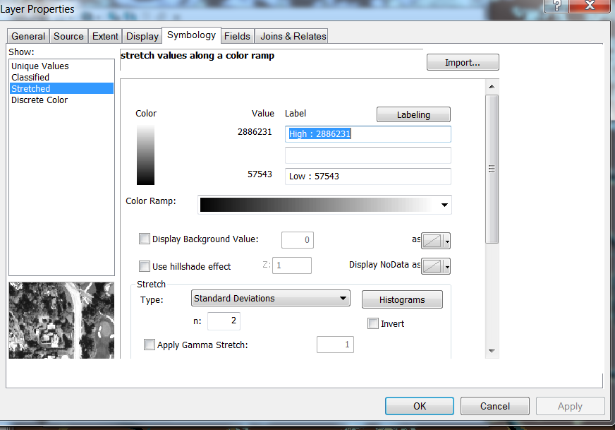

In Fields select Primary display field “aws0_999”

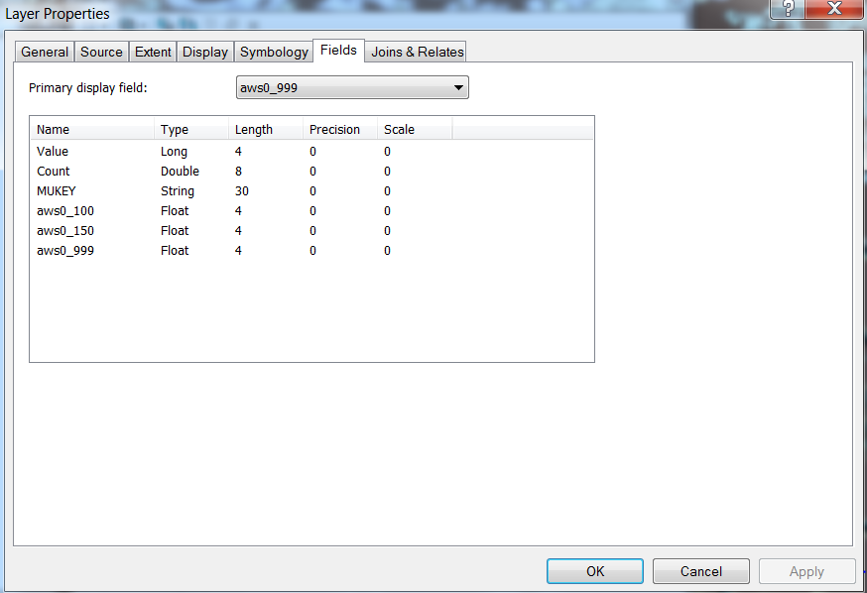

Edit Symbology to create colored categories of WHC. Edit into different ranges as needed for consistency across states. After completing the first one import symbology from it to the others to save time.

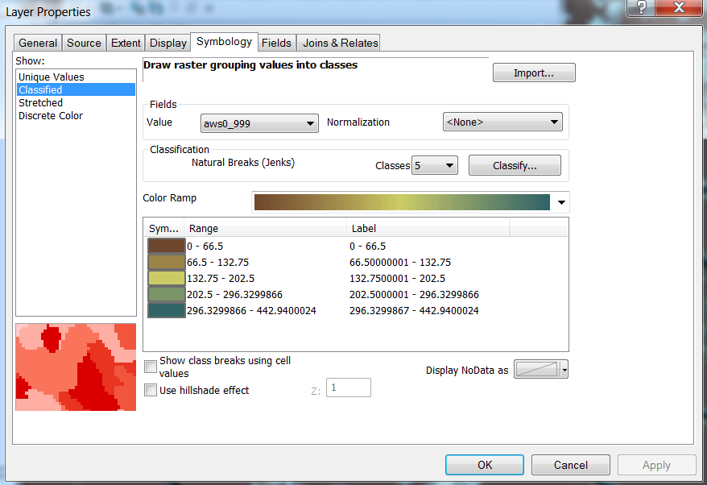

Click Classify button to view different options for classification.

Select Defined Interval and choose Interval size.

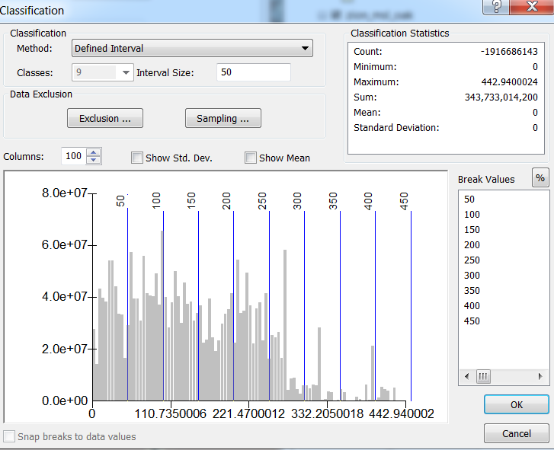

Slope and aspect

Create from a 30m DEM for the western U.S. This processing was done overnight in R using the following script (projection stuff not quite right at the moment-see work around below).

library(raster)

setwd("N:/ElevationData/")

## Not run:

elevation <- raster("westus_elev3")

elevation#gives file specs for elevation data set

#coord. ref. : +proj=aea +lat_1=20 +lat_2=60 +lat_0=40 +lon_0=-96 +x_0=0 +y_0=0 +ellps=GRS80 +towgs84=0,0,0,0,0,0,0 +units=m +no_defs

westus_slope<- terrain(elevation, opt = ('slope'), unit = 'degrees')

#change projection from Albers NAD83 to WGS84

#obtain coordinate system for an ndvi image

ndvi<-raster("C:\\MODIS\\temp\\tifs\\GRYN\\MOD13Q1.005_20150518180045\\MOD13Q1.A2000049.250m_16_days_NDVI.tif")

ndvi#gives file specs for ndvi image

#coord. ref. : +proj=longlat +datum=WGS84 +no_defs

#reproject raster from elevation data set to match ndvi

westus_slope_wgs84<-projectRaster(westus_slope,"+proj=aea +lat_1=20 +lat_2=60 +lat_0=40 +lon_0=-96 +x_0=0 +y_0=0 +ellps=GRS80 +towgs84=0,0,0,0,0,0,0 +units=m +no_defs",

"+proj=longlat +datum=WGS84 +no_defs",method='ngb')

plot(westus_slope_wgs84)

writeRaster(westus_slope,"westus_slope.tif",format='GTiff', prj=TRUE)

writeRaster(westus_asp,"westus_asp.tif",format='GTiff', prj=TRUE)

westus_asp<- terrain(elevation, opt = ('aspect'),unit = 'degrees')

#change projection from Albers NAD83 to WGS84

westus_asp_wgs84<-projectRaster(westus_as,"C:\\MODIS\\temp\\tifs\\GRYN\\MOD13Q1.005_20150518180045\\MOD13Q1.A2000049.250m_16_days_NDVI.tif")

writeRaster(westus_asp_wgs84,"westus_asp_wgs84.tif",format='tif', prj=TRUE)

windows()

plot(westus_asp_wgs84)

Reprojecting the enormous slope, aspect and soil grids proved troublesome in ArcMap so a work around is below.

Extract values to Points

In order to obtain water holding capacity, slope and aspect at point locations extract map data from rasters using the extraction at polygon centroid. Polygon centroids were created from shape files in R.

Before extracting you need your point data and raster data in same coordinate system. Either get everything in WGS_84 coordinate system to match ndvi, or make several versions of your point shape file projected in coordinate systems that match raster maps.

Open ArcToolbox and navigate to Project Raster and fill in dialog box as shown below.

WGS_84 is found at Geographic> World > WGS_84.

This won’t work on the western U.S. sized maps. See workaround below.

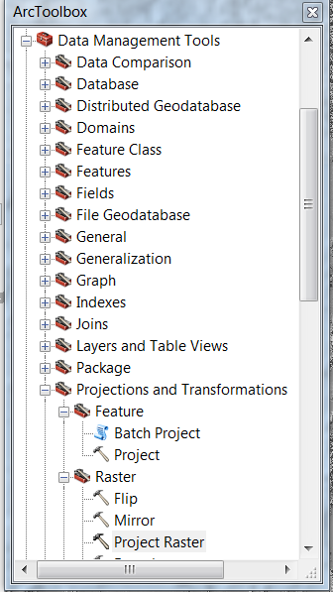

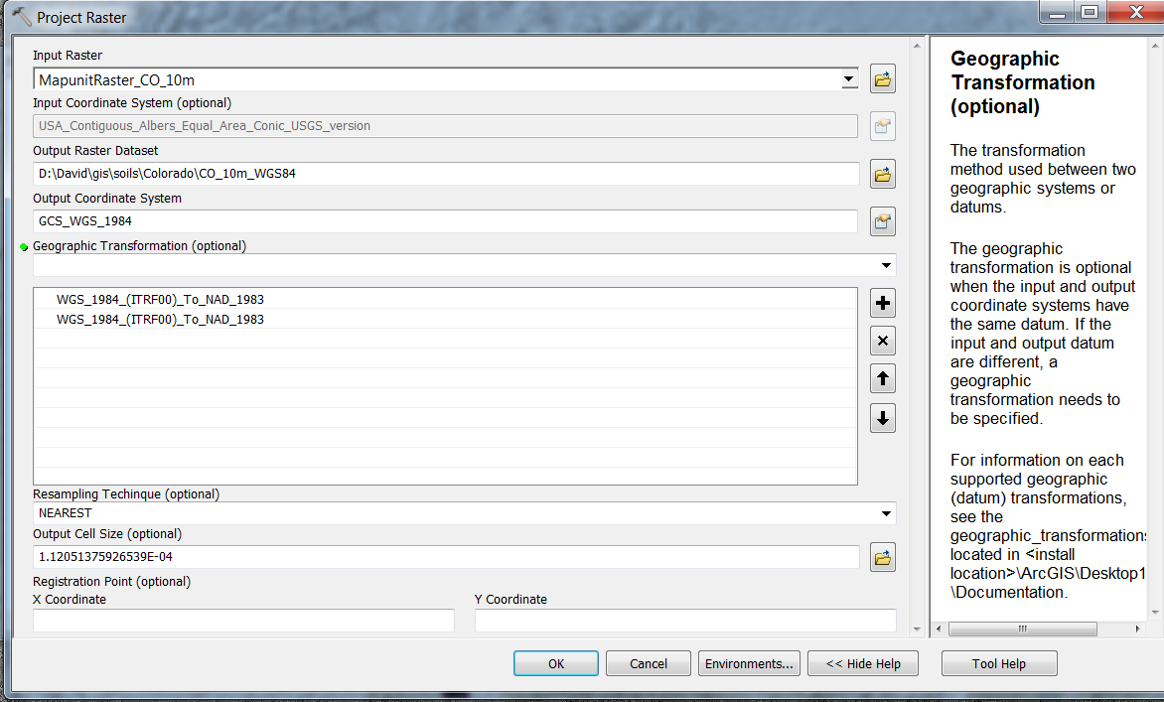

Alternatively reproject point file to match soil data and DEM as a work around.

gSSURGO are Albers equal area conic USGS which is NAD 83. The projection from WGS 84 to that projection is WGS_1984_(ITRF00)_To_NAD_1983

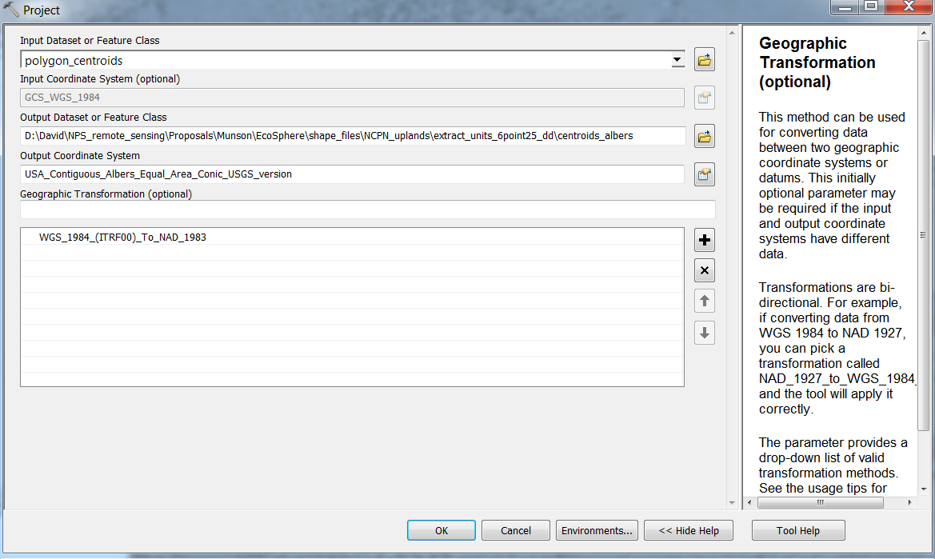

Extract values to points using spatial analyst in ArcToolbox will create a new shapefile of points that have the water holding capacity values in the attribute tables.

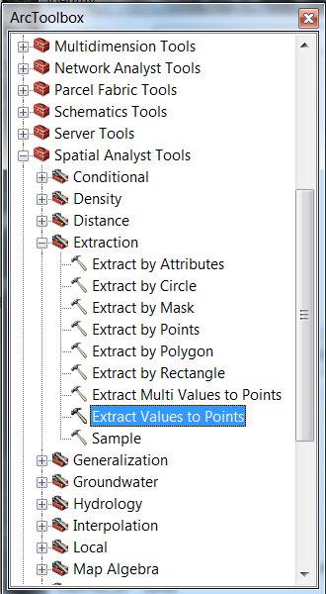

Complete the dialog box as follows, NOTE: You’ll have to save into the default geodatabase. 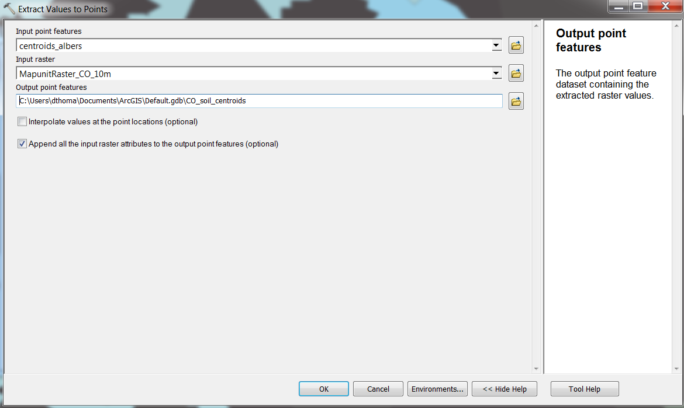

Unfortunately you can’t get a simple shape file out of it back into your working directory. So, to obtain the data as a text file open the attribute table from table of contents. Click the editor button in upper left of attribute table, then click select all

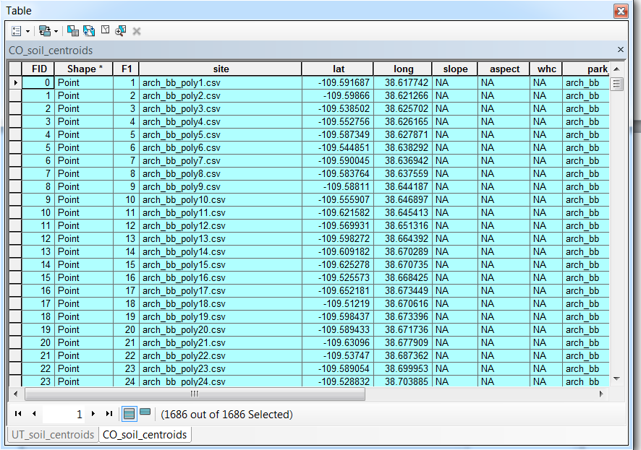

Click the editor button again then click export

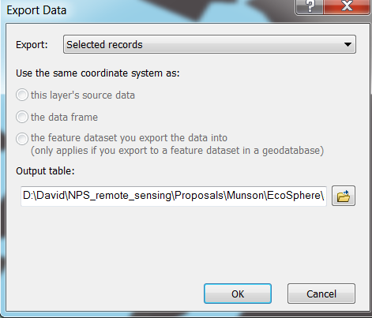

Click the folder icon, then in the drop down box select Save as file type Text file.

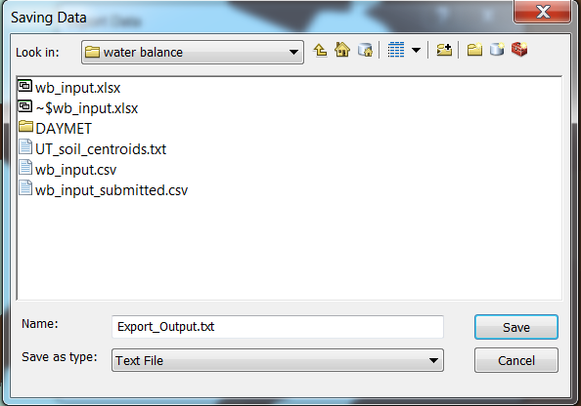

Following steps did not work b/c decimal places in output fields were randomly placed creating non-sense output. AWC for top meter might be 5.7, then top 1.5 meters 1.04, the whole profile 1.45. Real values should have been 57, 104 and 145, but there was no consistent pattern in decimal place shift by column. This may be due to environement settings? When the output file location changed to default path which is an ArcMap geodatabase the decimal placement was correct.

Extracting to points creates shapefiles and all their associated hidden sub files in your directory path. Open an instance of Excel then from within Excel click file, open and navigate to the *.dbf sub-shapefiles that contain the slope, aspect and soil water holding capacity data. Merge this data into your site attribute file that the water balance model accesses when it runs.

Copy attribute table from ArcMap to Excel

Right click on shape file name in Table of Contents, click select then select all. Click select again, then click Copy Records for Selected Features. That places the attribute table on the Windows clipboard and you can paste to Excel from there.

Another way to obtain point values for soil properties is to use the ArcMap tool box utility from NRCS called Soil Data Development Toolbox (google it, download and install it first).

In the gSSURGO mapping Toolset double click Map Soil Properties and Interps.

Select the map unit layer for the state of interest.

Select the SDV Folder “Soil Physical Properties” for SDV attribute % sand or % clay

Aggregation method choose weighted average

Bottom Depth choos 100 cm to coincide with water balance model depth.

This will create a Albers Equal Area map of the soil property of interest.

Reproject to Geographic > World>WGS_84 to match projection of extraction points, or alternatively reproject your points of interest to Albers Equal area before extracting.

NOTE: I had trouble with reprojection because it lost the soil attribute information of interest (% clay, sand, depth) so I ended up using a join in Albers projection to obtain the soil attribute data.

Join: Right click the points file > join > then follow instructions to make shapefile copy of points that have s

# **Exploring the influence of PET method, site and climate**

Open the companion sensitivity analysis calculator Penman vs Hamon effect on water balance.xlsx

In this file the climate input is a bogus repeated summer day without rain.  This lets us evaluate how soil dries without any moisture input or other climate variables influence on drying.

Specifically, play with the wind speed value and the water holding capacity value by changing values in cells CB6 and CC6.  Graphs will be updated automatically.

# **References**

Dingman, S.L., 2002. Physical Hydrology, 2nd ed. Prentice Hall, Upper Saddle River, NJ.

McCune, B. (2007). Improved estimates of incident radiation and heat load using non- parametric regression against topographic variables. Journal of Vegetation Science, 18(5), 751.

Sonntag D.: Important New Values of the Physical Constants of 1986, Vapour Pressure Formulations based on the IST-90 and Psychrometer Formulae; Z. Meteorol., 70 (5), pp. 340-344, 1990.

<http://irtfweb.ifa.hawaii.edu/~tcs3/tcs3/Misc/Dewpoint_Calculation_Humidity_Sensor_E.pdf>

Zotarelli, L, M. D. Dukes, C C. Romero, K. W. Migliaccio, and K. T. M. (2010). *Step by step calculation of the Penman-Monteith Evapotranspiration (FAO-56 Method)*. *Agricultural and Biological Engineering Department, Florida Cooperative Extension Service, Institute of Food and Agricultural Sciences, University of Florida.* http://doi.org/10.1016/j.scitotenv.2011.10.067